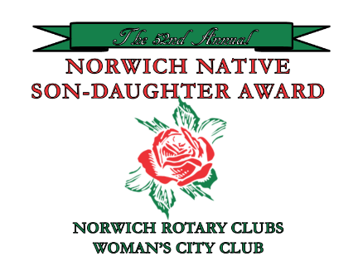
Nomination Form
Norwich Native
Son/Daughter Award

Sponsored by the Norwich Rotary Clubs and the Woman’s City Club of Norwich, I am pleased to nominate the following individual for the Norwich Native Son/Daughter Award for the year 2024. Name of Nominee: ___________________________________________________________
Address: ___________________________________________________________________
Telephone (if known): ________________________________________________________
Occupation: ________________________________________________________________
Local schools attended (if known): ______________________________________________
Summary of the nominee’s outstanding achievements: ______________________________ ___________________________________________________________________________
___________________________________________________________________________ Summary of the nominee’s Community and Charitable activities: ______________________ ___________________________________________________________________________
___________________________________________________________________________
___________________________________________________________________________ Please attach any additional or supporting information (magazine or newspaper articles, etc.)
Name of person making nomination: ____________________________________________
Address: ___________________________________________________________________
Telephone: _________________________________________________________________
I have read the criteria for nominations (second page or reverse side of this form) and certify that the nominee complies with them.
Signature: __________________________________________________________________
Date: ______________________________________________________________________
Please mail to: Norwich Native Son/Daughter Award, c/o Mary Richardson, 406 New London Road, Salem CT, 06420. Deadline for nominations is March 13, 2024.
Norwich Native Son/Daughter Award
Presented by
The Norwich Rotary Clubs
&
The Woman’s City Club of Norwich

Purpose:
The purpose of the Native Son/Daughter Award is to recognize outstanding achievements by Norwich, Connecticut natives who reached those achievements while living outside the Norwich area.
Eligibility:
- Nominees must have:
  - Been either born in Norwich or to parents who were residents of Norwich at the time of the nominee’s birth, and
  - Lived in Norwich during most of his/her life through high school. Persons who were born to parents residing in a bordering town at the time of that person’s birth may also be nominated, providing all of the following criteria are met in full:
i. Nominee moved into Norwich before beginning first grade, and ii. Continued to reside in Norwich through high school
- Nominee must also agree to receive the award in person at the Native Son/Daughter Award Luncheon in Norwich in the May/June timeframe.

